JOIN US FOR SUMMER FUN!!!
Affordable!! Professional! Fun!!
PRIVATE CAMPS—-DESIGNED JUST FOR YOU!!!!
Please email us to schedule your private camp
https://www.scau.org/contact-us
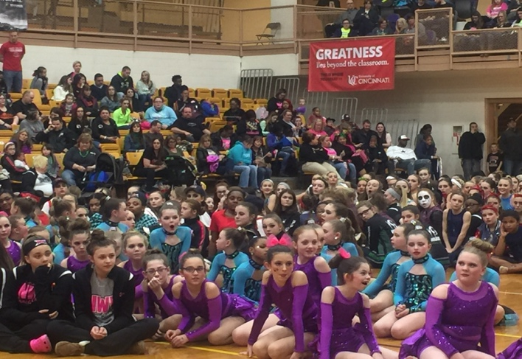
1 DAY: $90 PER DANCER
2 DAY: $125 PER DANCER
3 DAY: $135 PER DANCER
4 DAY: $155 PER DANCER
(50% deposit required to book instructors)
If choreographers are asked to choreograph
specific choreography, do formations, etc.,
there is an additional $200 choreography fee
which goes straight to the choreographer.
20-30 Dancers—-2 instructors
31-40 Dancers—-3 instructors
41+ Dancers—-4 + instructors
**If camp requires multiple levels occurring simultaneously, additional instructors will need to be hired to accommodate multiple levels (pricing to be determined).
Great material, innovative choreography AND we travel to YOU. We can customize your camp to fit your team’s needs and your team’s dates. Need technique work? We can do it! Need a lyrical routine for beginners? We can do it? You name it—we can design it your way! We can even design a hotel stay-away camp if you desire.
Also, our instructors are available to help you get ready for college dance tryouts, solo choreography, etc. Contact us for those prices.

YES, WE’D LIKE TO SCHEDULE A PRIVATE CAMP WITH SHOWCASE AMERICA UNLIMITED!
Team or Studio Name: ___________________________
Contact Person: ________________________________
Contact Email Address: __________________________
Contact Phone: ________________________________
Number of Days: ___________ DATE(S): ___________
**ALSO LIST ALTERNATE DATES IF THOSE ARE FILLED: ___________________________________________________________________
Hours: (example: 9-3 is most common) ____________
Approximate Number of Dancers:
10-20________ 21-30________ 31-40_______
40+_________
Please check all levels that apply so that our choreographers can prepare appropriate material
Beginner_____ Intermediate _____ Advanced ______
Preference for Instructor or Type of Expertise?
THEN...Tell us more about what types of instruction you would like, more about your dancers, more about what you’d like to schedule, instructor preferences.
Design it yourself! Brainstorm!!

